**Lesson22 Azure function With VS 2019**

**Steps: -**

**1-on VS 2019 > create new project > Azure Function**

**2-we select HTTP trigger > and naming it as SampleFunc**

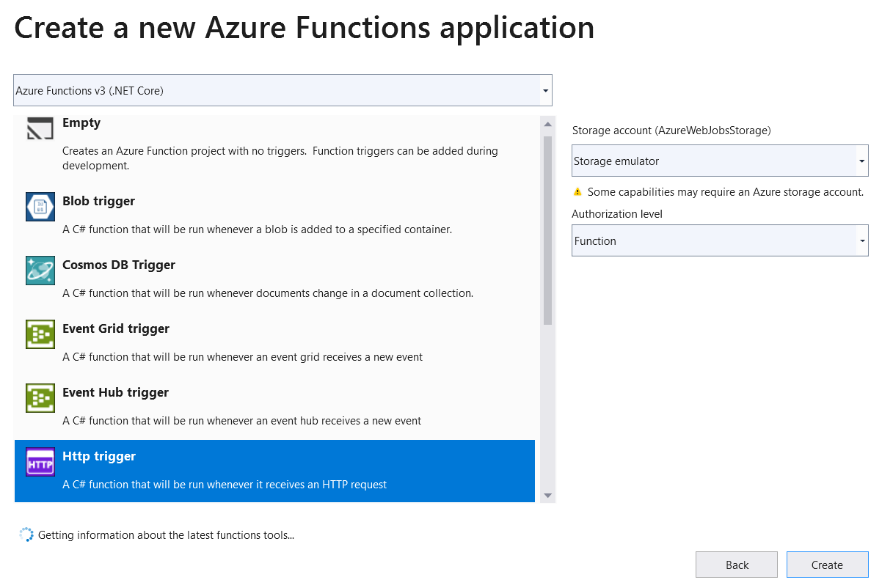

**3-on project > publish > select Azure function (Linux)**

